Skills for the Future Maritime Technology
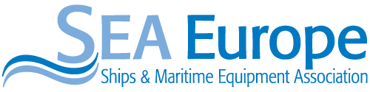
Final conference of the EU – funded
& Project
“Creating a European Skills Council for the Maritime Technology Sector”
01.03.2016, 10:00 - 13:00
European Parliament - Room PHS 5B001

Welcome speech
Mr Sergio COFFERATI, Searica Vice-President on Maritime Industries (5min)

Introduction
Mr Dariusz ROSATI, Member of the Intergroup (5min)

Ms Lowri EVANS, Director-General, Directorate-General Mobility and Transport (10min)

A European Skills Council for the Maritime Technology Sector:
Mr Ramón SARMIENTO, Co-Chairman of European Social Dialogue Committee for the Shipbuilding Sector (10min)

The European Maritime Technology Sector. Key facts and figures:
Mr Christophe TYTGAT, SEA Europe Secretary General (10min)

Skills Evaluation and challenges of technological developments - Sophie NORMAND, HR Director, DCNS Group and Coordinator of Campus Naval (10min)

Roundtable: moderated by Gesine MEISSNER, President of the Searica-Intergroup.

- Skills demand of the new labour market – Thorsten LUDWIG, IG Metal
- Good practices to match skills demand – Sophie Normand, DCNS Group & Campus Naval
- Maritime Technology as driver for regional development in Poland - Jerzy CZUCMAN, Director of Forum Okretowe
- The shipping sector´s perspective. Synergies and possible common training programmes -Christophe Tytgat, SEA Europe Secretary General

Open floor discussion / Q & A
Closing Remarks by Gesine MEISSNER, President of the Searica-Intergroup (5min)

Networking Lunch (12.30)

